Emerald Necklace Conservancy’s School Year Youth Leadership Program
Come get paid to have fun and learn about the environment!

The Youth Leadership Program combines nature connection, environmental education, career exploration, workforce development and fun for Boston residents between the ages of 15-18. The program runs from December 7 -April 30 (start date is subject to change). Participants will meet during the week for a total of 7.5-10 hours/week.

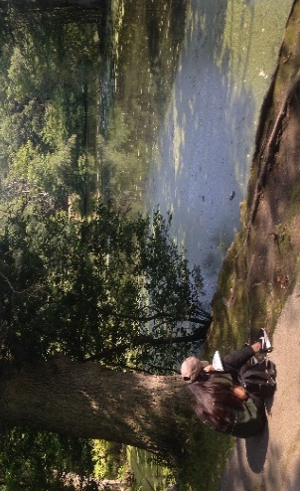
Participants will learn about everything from climate change, watersheds, how to how to create a nature journal, how to facilitate a presentation, observing bird language and much more. Explore what nature has to offer with the Emerald Necklace Conservancy’s Youth Leadership Program.
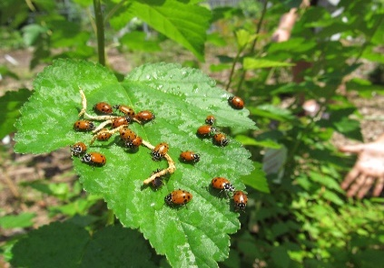

To apply, you must register with Boston’s Department of Youth Engagement and Employment first at youth.boston.gov. Registration begins November 1. Once registered, select the Emerald Necklace Conservancy under the Job Search tab. For more information or help with registering, contact Kent Jackson at kjackson@emeraldnecklace.org. Also, complete the attached application and return to Kent Jackson at kjackson@emeraldnecklace.org.
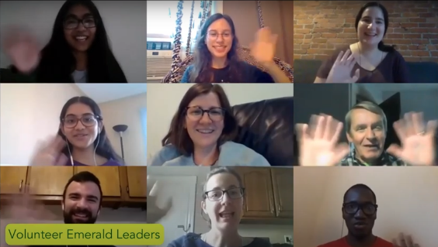
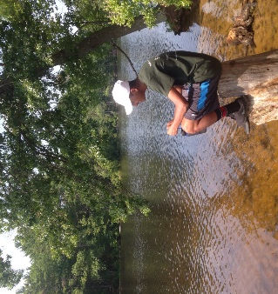

Who is eligible for Green Team?
- Residents of Boston who are enrolled in high-school or a GED program
- Must be between the ages of 15-18.

What is the schedule?
- Tuesdays-Thursdays from 3:30 pm-6:00 pm
- Pay rate: $13.50, pay rate will increase to $14.25 on January 1, 2022

